Thomas Fiocchi  
Assignment #6 questions

Professor Urness

1. Describe the difference between the Gouraud shading and Phong shading models. Include screenshots from your application to help strengthen your discussion.

Gouraud shading interpolates colors along the polygon for each pixel. This minimizes the abrupt changes between the colors of the adjacent polygons. It also approximates the normal to the surface at a vertex by averaging all normals of abutting polygons, and then calculates the intensity at each vertex using illumination equations. Phong shading, on the other hand, can achieve greater realism through highlighting shiny objects via an approximation of the normal vector at each pixel. Phong shading is useful for creating shininess and reflections.

Here is a picture of Gouraud shading:

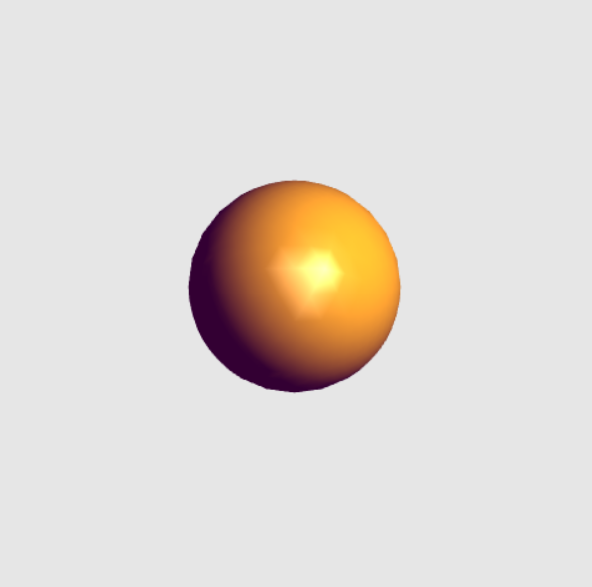

Here is a picture of Phong shading:

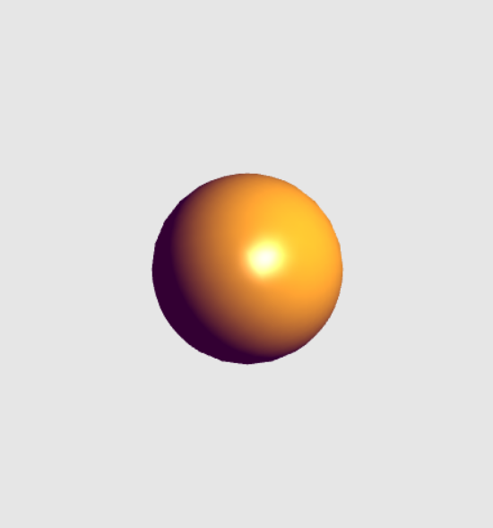

1. The Phong reflection model includes several non-physical (non-realistic) components in the model. List and describe these components that are not realistic and describe why they are made.

The three different not physical components in the Phong reflection model are Ambient, diffuse, and specular. These different components are used to represent different types of materials that can be rendered, producing different types of textures and lighting.